## Why is the cemetery dry

In response to California’s ongoing drought, Governor Brown’s April 1, 2015, Executive Order B-29-15 requires the State Water Resources Control Board to immediately implement water efficiency measures to reduce potable water usage at commercial, industrial, and industrial properties, including cemeteries, to result in a Statewide 25 percent reduction in potable water usage through February 28, 2016. Regulations to meet this requirement can be found on the State Water Resources Control Board website, www.waterboard.ca.gov.

California’s drought affects everyone, California cities, town, counties, special districts, residents, and businesses – cemeteries included – must follow Governor Brown’s Executive Order to conserve water. This means the cemetery you visit may look a little different than it usually does. In this brochure, the (Your Cemetery Name) Cemetery District, offers information for consumers on what they can expect from their cemetery.

.



Information for consumers regarding the current drought effect on the (Your District Name) Cemetery

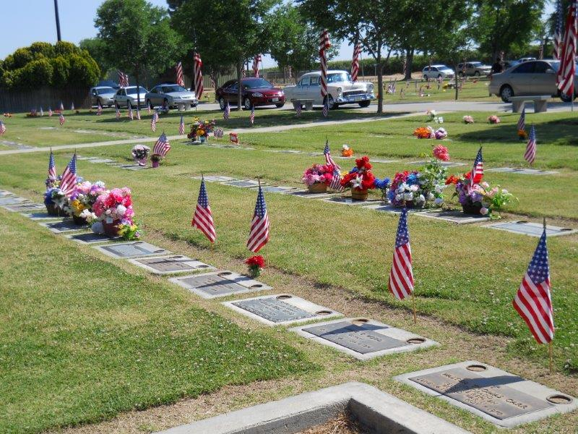

# Cemetery Drought Maintenance

Date of publication

Your Name

Cemetery District

Street Address

Mailing Address

Town, State, Zip

Phone:

Fax:

www.

[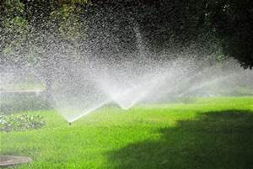](http://www.bing.com/images/search?q=irrigation+photo+free&view=detailv2&&id=D5C329F4254954B6CA08D6EFE112972078EF2200&selectedIndex=1&ccid=FPPXUqey&simid=608005226187263372&thid=JN.ghhtwDCGroQwzNo42T2FHA)

## water usage information

Because cemeteries may obtain water from different sources, the appearance of their turf and landscaping may differ from one property to another. The water efficiency measures that cemeteries must implement may result in less fertile landscaping and impact the appearance of the property. The (Your District Name) Cemetery District recognizes that this will occur as the State of California continues its important water conservation efforts. We will do our best to keep the grass as green as possible at the (Your District Name) Cemeteries and continue to work toward keeping the trees in each cemetery.

Here is the restriction information from the State regarding the (Your Cemetery Name) Cemetery District:

* Cemeteries that use recycled or reclaimed water are not restricted.
* Cemeteries with a “self-sufficient” water supply (such as a well) are required to reduce water usage by 25 percent or limit outdoor irrigation with potable water to no more than two days a week.
* Cemeteries that receive their water from another source (an urban water supplier or a water utility company) must comply with water efficiency measures implemented by their local water supplier.

## What consumers can expect

Title 16 of the California Code of Regulations (CCR) section 2333 (b) (3) reads as follows:

*“Each endowment care cemetery shall perform, at a minimum, the following maintenance on its cemetery property…..Provide a sufficient supply of water to keep grass and plants as green as seasonable possible in accordance with natural terrain, availability of water, and local or county ordinances regarding water use.”*

## What the cemetery District is doing

(This is an example-Personalize for your District.)

In the Water Action Plan adopted by the Cemetery on June 18, 2015, the cemetery has a plan in place to support the Executive Order B-29-15 and to remain in compliance as long as it remains in effect. To accomplish this fact the cemetery has put in place a water reduction plan that implements a ‘best practices’ for the cemetery.

In summary this plan requires and coordinates the following:

* Remove high water consuming ornamental plants and replacing them with water tolerant plants.
* Replace inefficient irrigation and retrofit as best possible to a high efficiency irrigation system.
* Reduce water consumption at a minimum of 25% on all turf areas and maintain a minimal amount of turf and keep the trees alive.
* Eliminate turf areas which may be determined to be extraneous.

For more information, visit

Your District Contact Info.